PNEUMONIA DETECTION USING CNN BASED CLASSIFICATION

INTRODUCTION

What is python?

 Python is an object-oriented, high-level programming language with integrated dynamic semantics primarily for web and app development. It is extremely attractive in the field of Rapid Application Development because it offers dynamic typing and dynamic binding options.

What is Artificial Intelligence?

The theory and development of computer systems able to perform tasks normally requiring human intelligence, such as visual perception, speech recognition, decision-making, and translation between languages.

PROBLEM STATEMENT

The problem is to detect pneumonia on a faster pace. Solving this problem would help doctors easily detect pneumonia rather than time consuming tests. The method we used to solve this problem is Convolutional neural networks based classification in which the system would be trained by feeding the images of chest x-ray .These images are contained in a dataset which is taken from Kaggle.

Five W’s Of Problem Statement

Who:

The problem is among people affected by pneumonia.

What:

If the problem was not solved it would be time consuming to detect pneumonia.

When:

When the patient is under highly critical situation and time cannot be spared for various tests, so the problem needs to be fixed.

Why:

To utilize time for better cure rather than spending time for performing tests.

Where:

This developed model is a user-end product for neurologists in the field of medical science

DATA COLLECTION

<https://www.kaggle.com/paultimothymooney/chest-xray-pneumonia>

METHODOLOGY

Exploratory Data Analysis

Figures And Tables

Confusion Matrix

*Actual*

Yes No

*Prediction*

|  |  |
| --- | --- |
| TP  160 | FP  161 |
| FN  74 | TN  229 |

Chest X-ray Images

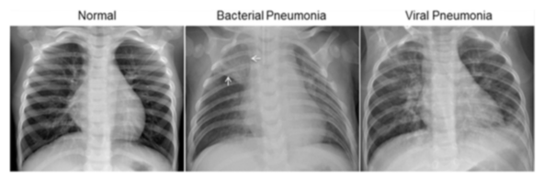

Data Modelling

Convolutional Neural Network Based Classification

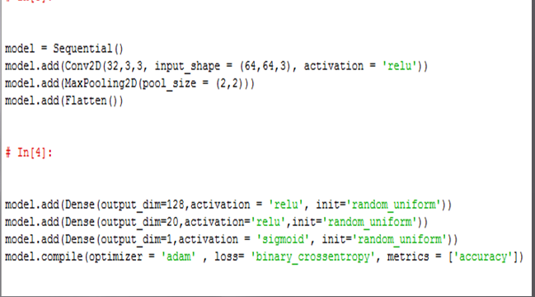

FINDINGS AND SUGGESTIONS

This model is a research oriented project which could be further expanded in the future to obtain higher accuracy and give even better results.

CONCLUSION

This developed model has an accuracy of 64% which can be further improved. The software beats previous conventional methods to detect pneumonia. This is an AI powered imaging software which can help doctors diagnose pneumonia with greater accuracy than ever before.